GIT commands
REBASE
Modify commit history by moving or combining commits. Keep your feature branch up to date with the latest code from the main branch, but without creating a merge commit.
BISECT
Pick and choose specific commits from one branch and apply them to another branch

Step - 1 $ git rebase -i head~7
Head(7) is the number of commits that you have in your branch.
Step - 2 Then press Insert key and replace the pick word with s for the commits and leave the 1st commit pick as usual because we are squashing it to this commit.
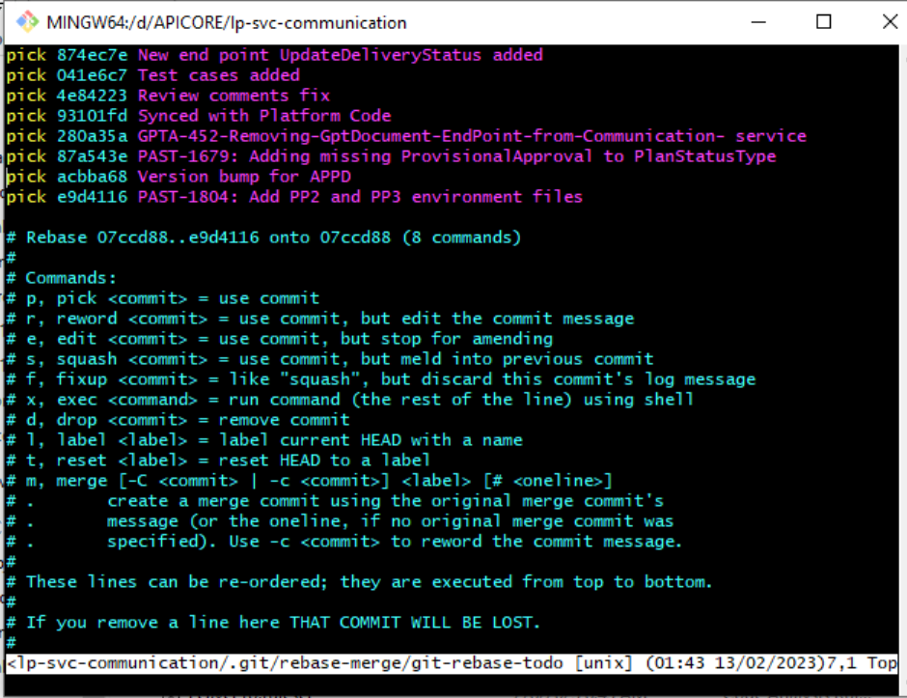

Step - 3 Then press Escape
Step - 4 Add :wq
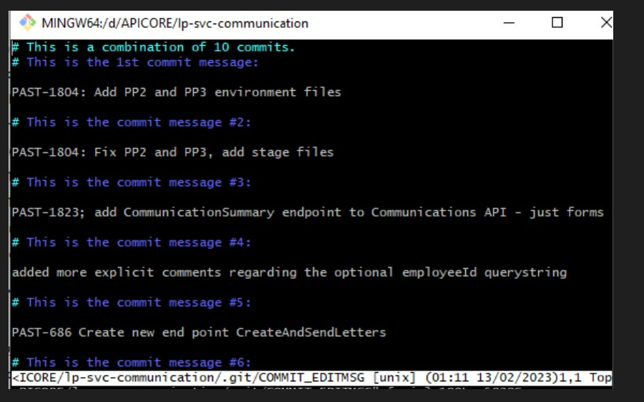
Step - 5 Then # hash your commits name
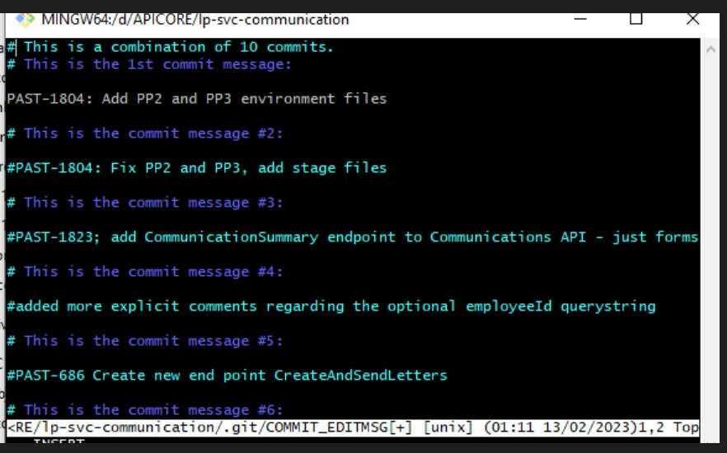
Step - 6 Then Again :wq
Step - 7 finally $ git push -f to push your changes
To Abort the changes before push use $ git rebase –abort

Resolve Merge conflict
- Use git rebase develop / git pull origin develop --rebase
- Then it pulls files in VS of your branch
- Then accept merge like stash
- Then git rebase --continue
- Then git push –f

Cherry Pick
For Cherry Pick use git cherry-pick<commit-hash>
Git cherry-pick –continue

Remove Commit
commit removing without create the branch in git bash codes :
git log --oneline viewing recent comitts
git reset --soft HEAD^1 removing lastest commit
git push -f pushing commit after deleting our commit

after this take a pull in master branch our changes is gone.

